**How to Update/Flash MAC Address**

NXP layscape SoC based boards have System-ID EEPROM to stores important configuration data about the board, including the following:

* Board serial number
* Board errata indicators
* Manufacturing build date
* MAC addresses for each ethernet port
* Temperature calibration factors

The System-ID EEPROM is typically programmed at the factory as part of the manufacturing process and is subsequently write-protected for security.

When not programmed in factory, below are the steps can be followed to program correct MAC addresses.

**Example - FRWY-LS1046A**

FRWY-LS1046A boards come with four mac address , stick on the QSGMII connector as shown below.

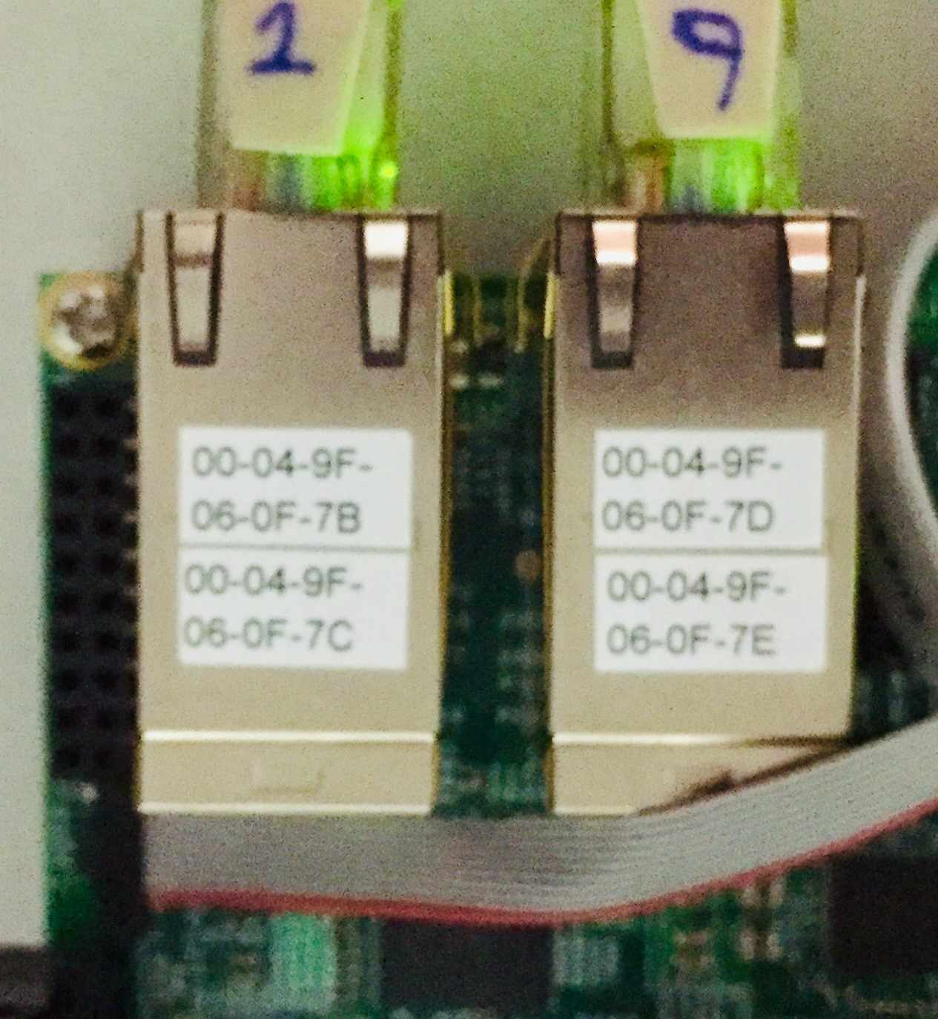

Below are the command to update/store the mac address during production.

Example - In the above picture board is having four MAC address 00:04:9f:06:0f:7b , 00:04:9f:06:0f:7c , 00:04:9f:06:0f:7d , 00:04:9f:06:0f:7e .

Let’s say the date and time mac address programmed is 2019/03/19 16:45:04

At u-boot prompt

=> mac read

=> mac id

=> mac num TR17110038

=> mac errata 1.0

=> mac date 190319164504

=>  mac ports 4

=>  mac  0 00:04:9f:06:0f:7b

=> mac  1 00:04:9f:06:0f:7c

=>  mac  2 00:04:9f:06:0f:7d

=>  mac  3 00:04:9f:06:0f:7e

=> mac save

=> mac

ID: NXID v1

SN: TR17110038

Errata: 1.0

Build date: 2019/03/19 16:45:04

Eth0: 00:04:9f:06:0f:7b

Eth1: 00:04:9f:06:0f:7c

Eth2: 00:04:9f:06:0f:7d

Eth3: 00:04:9f:06:0f:7e

CRC: b15f32c6

=>

|  |  |  |
| --- | --- | --- |
| **Field Name** | **Description** | Comment’s(If Any) |
| TagID | EEPROM Tag:  Always the four ISO-8859 characters “NXID”, with no null termination  If not found, the EEPROM may not be initialized, or may reside on a different I2C  interface. |  |
| SN | Serial Number:  From 0 to 11 ISO-8859 characters of board/system serial number data, terminated by a  NULL character |  |
| ERRATA | Errata Level:  From 0 to 4 ISO-8859 characters of board/system errata data, terminated by a NULL  character |  |
| DATE[0:5] | Build Date:  A field showing the manufacturing build date and time, in BCD format, is as follows:  0: YY year, a BCDvalue from 0x00 to 0x99  1: MM month, a BCD value from 0x01 to 0x12  2: DD day, a BCD value from 0x00 to 0x31  3: hh hour, a BCD value from 0x00 to 0x23 (24-hour format)  4: mm minute, a BCD value from 0x00 to 0x59  5: ss seconds, a BCD value from 0x00 to 0x59 |  |
| VERSION | NXID Version:  A 32-bit integer field containing NXID SystemID format revision information is as follows:  0: Original version  1: Current (expanded) version |  |
| MACSIZE | MAC table size:  A value indicating how many valid MAC addresses are stored in the MAC1–MAC8 fields  (version 0) or MAC1–MAC8 + MAC9–MAC16 fields (version 1 or later). |  |
| MAC1  MAC2  MAC3  MAC4  MAC5  MAC6  MAC7  MAC8 | MAC addresses:  6 hex digits representing the MAC address for Ethernet ports 1 through 8  Fields with an address greater than MACSIZE may have undefined values and should  not be used. |  |
| CRC32 | Checksum (version = 0):  32-bit CRC value of bytes 0x00 through 0x71, inclusive |  |

**Configuring MAC Address in U-Boot**

U-Boot 2018.09-gf851eafae4 (Apr 03 2019 - 10:06:59 +0800)

SoC:  LS1046AE Rev1.0 (0x87070010)

Clock Configuration:

       CPU0(A72):1800 MHz  CPU1(A72):1800 MHz  CPU2(A72):1800 MHz

       CPU3(A72):1800 MHz

       Bus:      700  MHz  DDR:      2100 MT/s  FMAN:     800  MHz

Reset Configuration Word (RCW):

       00000000: 0e150012 10000000 00000000 00000000

       00000010: 30400506 00800012 40025000 c1000000

       00000020: 00000000 00000000 00000000 00038800

       00000030: 20044100 24003101 00000096 00000001

Model: LS1046A FRWY Board

Board: LS1046AFRWY, Rev: A, boot from QSPI

SD1_CLK1 = 100.00MHZ, SD1_CLK2 = 100.00MHZ

I2C:   ready

DRAM:  3.9 GiB (DDR4, 64-bit, CL=15, ECC on)

SEC0: RNG instantiated

Using SERDES1 Protocol: 12352 (0x3040)

Using SERDES2 Protocol: 1286 (0x506)

NAND:  512 MiB

MMC:   FSL_SDHC: 0

Loading Environment from SPI Flash... SF: Detected mt25qu512a with page size 256 Bytes, erase size 64 KiB, total 64 MiB

*** Warning - bad CRC, using default environment /

EEPROM: Invalid ID (ff ff ff ff)

In:    serial

Out:   serial

Err:   serial

Net:   SF: Detected mt25qu512a with page size 256 Bytes, erase size 64 KiB, total 64 MiB

Fman1: Uploading microcode version 106.4.18

PCIe0: pcie@3400000 disabled

PCIe1: pcie@3500000 Root Complex: no link

PCIe2: pcie@3600000 Root Complex: x1 gen1

e1000: 68:05:ca:1c:02:c4

       FM1@DTSEC1

Error: FM1@DTSEC1 address not set.

, FM1@DTSEC5

Error: FM1@DTSEC5 address not set.

, FM1@DTSEC6

Error: FM1@DTSEC6 address not set.

, FM1@DTSEC10

Error: FM1@DTSEC10 address not set.

, e1000#0

Hit any key to stop autoboot:  0

=> mac read

=> mac id

=> mac num TR17110038

=> mac errata 1.0

=> mac date 190319164504

=>  mac ports 4

=>  mac  0 00:04:9f:06:0f:7b

=> mac  1 00:04:9f:06:0f:7c

=>  mac  2 00:04:9f:06:0f:7d

=>  mac  3 00:04:9f:06:0f:7e

=> mac save

Programming passed.

=> mac

ID: NXID v1

SN: TR17110038

Errata: 1.0

Build date: 2019/03/19 16:45:04

Eth0: 00:04:9f:06:0f:7b

Eth1: 00:04:9f:06:0f:7c

Eth2: 00:04:9f:06:0f:7d

Eth3: 00:04:9f:06:0f:7e

CRC: b15f32c6

=>

**Verify Configured MAC Address in Linux**

 Reboot the board

U-Boot 2018.09-gf851eafae4 (Apr 03 2019 - 10:06:59 +0800)

SoC:  LS1046AE Rev1.0 (0x87070010)

Clock Configuration:

       CPU0(A72):1800 MHz  CPU1(A72):1800 MHz  CPU2(A72):1800 MHz

       CPU3(A72):1800 MHz

       Bus:      700  MHz  DDR:      2100 MT/s  FMAN:     800  MHz

Reset Configuration Word (RCW):

       00000000: 0e150012 10000000 00000000 00000000

       00000010: 30400506 00800012 40025000 c1000000

       00000020: 00000000 00000000 00000000 00038800

       00000030: 20044100 24003101 00000096 00000001

Model: LS1046A FRWY Board

Board: LS1046AFRWY, Rev: A, boot from QSPI

SD1_CLK1 = 100.00MHZ, SD1_CLK2 = 100.00MHZ

I2C:   ready

DRAM:  3.9 GiB (DDR4, 64-bit, CL=15, ECC on)

SEC0: RNG instantiated

Using SERDES1 Protocol: 12352 (0x3040)

Using SERDES2 Protocol: 1286 (0x506)

NAND:  512 MiB

MMC:   FSL_SDHC: 0

Loading Environment from SPI Flash... SF: Detected mt25qu512a with page size 256 Bytes, erase size 64 KiB, total 64 MiB

OK

EEPROM: NXID v1

In:    serial

Out:   serial

Err:   serial

Net:   SF: Detected mt25qu512a with page size 256 Bytes, erase size 64 KiB, total 64 MiB

Fman1: Uploading microcode version 106.4.18

PCIe0: pcie@3400000 disabled

PCIe1: pcie@3500000 Root Complex: no link

PCIe2: pcie@3600000 Root Complex: x1 gen1

e1000: 68:05:ca:1c:02:c4

       FM1@DTSEC1, FM1@DTSEC5, FM1@DTSEC6, FM1@DTSEC10, e1000#0

Hit any key to stop autoboot:  0

=>

root@localhost:~# ifconfig -a

docker0: flags=4099<UP,BROADCAST,MULTICAST>  mtu 1500

        inet 172.17.0.1  netmask 255.255.0.0  broadcast 172.17.255.255

        ether 02:42:99:77:9f:6c  txqueuelen 0  (Ethernet)

        RX packets 0  bytes 0 (0.0 B)

        RX errors 0  dropped 0  overruns 0  frame 0

        TX packets 0  bytes 0 (0.0 B)

        TX errors 0  dropped 0 overruns 0  carrier 0  collisions 0

enP1p1s0: flags=4098<BROADCAST,MULTICAST>  mtu 1500

        ether 68:05:ca:1c:02:c4  txqueuelen 1000  (Ethernet)

        RX packets 0  bytes 0 (0.0 B)

        RX errors 0  dropped 0  overruns 0  frame 0

        TX packets 0  bytes 0 (0.0 B)

        TX errors 0  dropped 0 overruns 0  carrier 0  collisions 0

        device interrupt 74  memory 0x50400c0000-50400e0000

fm1-mac1: flags=4098<BROADCAST,MULTICAST>  mtu 1500

        ether 00:04:9f:06:0f:7b  txqueuelen 1000  (Ethernet)

        RX packets 0  bytes 0 (0.0 B)

        RX errors 0  dropped 0  overruns 0  frame 0

        TX packets 0  bytes 0 (0.0 B)

        TX errors 0  dropped 0 overruns 0  carrier 0  collisions 0

        device memory 0x1ae0000-1ae0fff

fm1-mac5: flags=4098<BROADCAST,MULTICAST>  mtu 1500

        ether 00:04:9f:06:0f:7c  txqueuelen 1000  (Ethernet)

        RX packets 0  bytes 0 (0.0 B)

        RX errors 0  dropped 0  overruns 0  frame 0

        TX packets 0  bytes 0 (0.0 B)

        TX errors 0  dropped 0 overruns 0  carrier 0  collisions 0

        device memory 0x1ae8000-1ae8fff

fm1-mac6: flags=4098<BROADCAST,MULTICAST>  mtu 1500

        ether 00:04:9f:06:0f:7d  txqueuelen 1000  (Ethernet)

        RX packets 0  bytes 0 (0.0 B)

        RX errors 0  dropped 0  overruns 0  frame 0

        TX packets 0  bytes 0 (0.0 B)

        TX errors 0  dropped 0 overruns 0  carrier 0  collisions 0

        device memory 0x1aea000-1aeafff

fm1-mac10: flags=4098<BROADCAST,MULTICAST>  mtu 1500

        ether 00:04:9f:06:0f:7e  txqueuelen 1000  (Ethernet)

        RX packets 0  bytes 0 (0.0 B)

        RX errors 0  dropped 0  overruns 0  frame 0

        TX packets 0  bytes 0 (0.0 B)

        TX errors 0  dropped 0 overruns 0  carrier 0  collisions 0

        device memory 0x1af2000-1af2fff

lo: flags=73<UP,LOOPBACK,RUNNING>  mtu 65536

        inet 127.0.0.1  netmask 255.0.0.0

        inet6 ::1  prefixlen 128  scopeid 0x10<host>

        loop  txqueuelen 1000  (Local Loopback)

        RX packets 80  bytes 5920 (5.9 KB)

        RX errors 0  dropped 0  overruns 0  frame 0

        TX packets 80  bytes 5920 (5.9 KB)

        TX errors 0  dropped 0 overruns 0  carrier 0  collisions 0

lxcbr0: flags=4099<UP,BROADCAST,MULTICAST>  mtu 1500

        inet 10.0.3.1  netmask 255.255.255.0  broadcast 0.0.0.0

        ether 00:16:3e:00:00:00  txqueuelen 1000  (Ethernet)

        RX packets 0  bytes 0 (0.0 B)

        RX errors 0  dropped 0  overruns 0  frame 0

        TX packets 0  bytes 0 (0.0 B)

        TX errors 0  dropped 0 overruns 0  carrier 0  collisions 0

sit0: flags=128<NOARP>  mtu 1480

        sit  txqueuelen 1000  (IPv6-in-IPv4)

        RX packets 0  bytes 0 (0.0 B)

        RX errors 0  dropped 0  overruns 0  frame 0

        TX packets 0  bytes 0 (0.0 B)

        TX errors 0  dropped 0 overruns 0  carrier 0  collisions 0

virbr0: flags=4099<UP,BROADCAST,MULTICAST>  mtu 1500

        inet 192.168.122.1  netmask 255.255.255.0  broadcast 192.168.122.255

        ether 52:54:00:06:b5:0b  txqueuelen 1000  (Ethernet)

        RX packets 0  bytes 0 (0.0 B)

        RX errors 0  dropped 0  overruns 0  frame 0

        TX packets 0  bytes 0 (0.0 B)

        TX errors 0  dropped 0 overruns 0  carrier 0  collisions 0

virbr0-nic: flags=4098<BROADCAST,MULTICAST>  mtu 1500

        ether 52:54:00:06:b5:0b  txqueuelen 1000  (Ethernet)

        RX packets 0  bytes 0 (0.0 B)

        RX errors 0  dropped 0  overruns 0  frame 0

        TX packets 0  bytes 0 (0.0 B)

        TX errors 0  dropped 0 overruns 0  carrier 0  collisions 0

root@localhost:~#